Bahria University,

Karachi Campus



LAB EXPERIMENT NO.

**11**

LIST OF TASKS

|  |  |
| --- | --- |
| TASK NO | OBJECTIVE |
| 1 | Create CRUD application using Webform in ASP.Net for Employees table as discussed in class. |
|  |  |
|  |  |
|  |  |
|  |  |
|  |  |
|  |  |
|  |  |
|  |  |
|  |  |

Submitted On:

Date: 28/06/2022

**Task No. 1: Create After Insert , After Update , After Delete**

**Triggers on Shippers Table in Northwind Database. Record query and their respective results in output.**

**Solution:**

**Triggers:-**

create TRIGGER [shipperInsertTrigger]

ON [Shippers]

for INSERT

AS

declare @shipperid int,@companyName nvarchar(40),@phone nvarchar(24),@audit_action

nvarchar(100)

BEGIN

-- Insert statements for trigger here

select @shipperid = i.shipperid from inserted i

select @companyName = i.companyName from inserted i

select @phone = i.phone from inserted i

set @audit_action = 'Inserted Record -- After insert trigger'

insert into Shippers_Audit values

(@shipperid,@companyName,@phone,@audit_action,GETDATE())

print 'After insert trigger on shippers table fired'

END

create TRIGGER [dbo].[tgrAfterUpdate]

ON [dbo].[Shippers]

FOR UPDATE

AS

declare @shipperid int,@companyName nvarchar(40),@phone nvarchar(24),@auditAction

nvarchar(100)

BEGIN

-- Insert statements for trigger here

select @shipperid = i.shipperid from inserted i

select @companyName = i.companyName from inserted i

select @phone = i.phone from inserted i

select @auditAction = 'Updated Record -- After Update Trigger'

insert into Shippers_Audit values

(@shipperid,@companyName,@phone,@auditAction,GETDATE())

print 'After update trigger on shipper table fired'

END

CREATE TRIGGER shipperDeleteTrigger

ON Shippers

FOR DELETE

AS

declare @shipperid int,@companyName nvarchar(40),@phone nvarchar(24),@audit_action

nvarchar(100)

BEGIN

-- Insert statements for trigger here

select @shipperid = d.shipperid from deleted d

select @companyName = d.companyName from deleted d

select @phone = d.phone from deleted d

set @audit_action = 'Deleted Record -- After delete trigger'

insert into Shippers_Audit values

(@shipperid,@companyName,@phone,@audit_action,GETDATE())

print 'After delete trigger on shippers table fired'

END

**Output:**

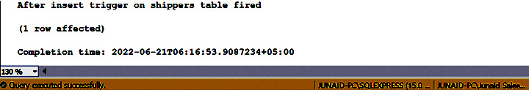insert into Shippers values ('Telnet','03152655451')

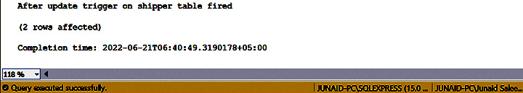update shippers set Phone = '032121565949' where CompanyName = 'Telnet'

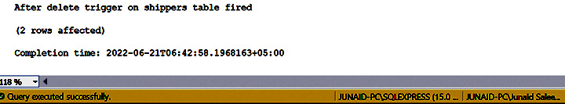delete Shippers where CompanyName = 'Telnet'

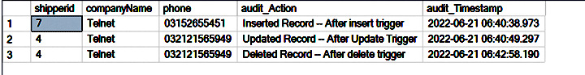**Audit Table: -**

**Task No. 2: Create Instead of Insert , Instead of Update , Instead of Delete**

**Triggers on Orders Table in Northwind Database. Record query and their respective results in output.**

**Solution:**

**Audit Table: -**

create table OrdersAudit( OrderID int not null, CustomerID nchar(5), EmployeeID int, OrderDate datetime,

RequiredDate datetime, ShippedDate datetime, ShipVia int , Freight money, ShipName nvarchar(40),

ShipAddress nvarchar(60), ShipCity nvarchar(20), ShipRegion nvarchar(20), ShipPostalCode nvarchar(10),

ShipCountry nvarchar(20), ActionPerformed nvarchar(50), ActionTimestamp datetime )

**Triggers: -**

CREATE TRIGGER ordersInsteadOfInsertTrigger

ON orders

INSTEAD OF INSERT AS

DECLARE

@ord_id int, @cust_id nchar(5), @emp_id int, @ord_date datetime, @req_date datetime, @ship_date datetime,

@ship_via int, @freight money, @ship_name nvarchar(40), @ship_add nvarchar(60), @ship_city nvarchar(15),

@ship_region nvarchar(15), @ship_post_code nvarchar(10), @ship_count nvarchar(15), @audit_action nvarchar(100)

select @ord_id = i.OrderID from inserted i

select @cust_id = i.CustomerID from inserted i

select @emp_id = i.EmployeeID from inserted i

select @ord_date = i.OrderDate from inserted i

select @req_date = i.RequiredDate from inserted i

select @ship_date = i.ShippedDate from inserted i

select @ship_via = i.ShipVia from inserted i

select @freight = i.Freight from inserted i

select @ship_name = i.ShipName from inserted i

select @ship_add = i.ShipAddress from inserted i

select @ship_city = i.ShipCity from inserted i

select @ship_region = i.ShipRegion from inserted i

select @ship_post_code = i.ShipPostalCode from inserted i

select @audit_action = 'Insert'

BEGIN

-- Insert statements for trigger here

BEGIN TRANSACTION

if (@emp_id > 8)

begin

print 'Cannot insert data because it is not fulfilling the requirement of employee

id'

rollback

end

else

begin

insert into OrdersAudit values

(@ord_id,@cust_id,@emp_id,@ord_date,@req_date,@ship_date,@ship_via,@freight,@ship_name,@ship_add,@ship_city,@ship_region,@ship_post_code,@ship_count,@audit_action,GETDATE())

commit

end

END

go

CREATE TRIGGER ordersInsteadOfUpdateTrigger

ON orders

INSTEAD OF UPDATE

AS

DECLARE

@ord_id int, @cust_id nchar(5), @emp_id int, @ord_date datetime, @req_date datetime, @ship_date datetime,

@ship_via int, @freight money, @ship_name nvarchar(40), @ship_add nvarchar(60), @ship_city nvarchar(15),

@ship_region nvarchar(15), @ship_post_code nvarchar(10), @ship_count nvarchar(15), @audit_action nvarchar(100)

select @ord_id = i.OrderID from inserted i

select @cust_id = i.CustomerID from inserted i

select @emp_id = i.EmployeeID from inserted i

select @ord_date = i.OrderDate from inserted i

select @req_date = i.RequiredDate from inserted i

select @ship_date = i.ShippedDate from inserted i

select @ship_via = i.ShipVia from inserted i

select @freight = i.Freight from inserted i

select @ship_name = i.ShipName from inserted i

select @ship_add = i.ShipAddress from inserted i

select @ship_city = i.ShipCity from inserted i

select @ship_region = i.ShipRegion from inserted i

select @ship_post_code = i.ShipPostalCode from inserted i

select @ship_count = i.ShipCountry from inserted i

select @audit_action = 'Update'

BEGIN

-- Insert statements for trigger here

BEGIN TRANSACTION

if (@freight < 50)

begin

print 'Cannot update data because it is not fulfilling the requirement of freight'

rollback

end

else

begin

insert into OrdersAudit values

(@ord_id,@cust_id,@emp_id,@ord_date,@req_date,@ship_date,@ship_via,@freight,@ship_name,@ship_add,@ship_city,@ship_region,@ship_post_code,@ship_count,@audit_action,GETDATE())

commit

end

END

go

CREATE TRIGGER ordersInsteadOfDeleteTrigger

ON orders

INSTEAD OF DELETE

AS

DECLARE

@ord_id int, @cust_id nchar(5), @emp_id int, @ord_date datetime, @req_date datetime, @ship_date datetime,

@ship_via int, @freight money, @ship_name nvarchar(40), @ship_add nvarchar(60), @ship_city nvarchar(15),

@ship_region nvarchar(15), @ship_post_code nvarchar(10), @ship_count nvarchar(15), @audit_action nvarchar(100)

select @ord_id = d.OrderID from deleted d

select @cust_id = d.CustomerID from deleted d

select @emp_id = d.EmployeeID from deleted d

select @ord_date = d.OrderDate from deleted d

select @req_date = d.RequiredDate from deleted d

select @ship_date = d.ShippedDate from deleted d

select @ship_via = d.ShipVia from deleted d

select @freight = d.Freight from deleted d

select @ship_name = d.ShipName from deleted d

select @ship_add = d.ShipAddress from deleted d

select @ship_city = d.ShipCity from deleted d

select @ship_region = d.ShipRegion from deleted d

select @ship_post_code = d.ShipPostalCode from deleted d

select @ship_count = d.ShipCountry from deleted d

select @audit_action = 'Delete'

BEGIN

-- Insert statements for trigger here

BEGIN TRANSACTION

if (@freight > 70)

begin

print 'Cannot Delete data because it is not fulfilling the requirement of freight'

rollback

end

else

begin

insert into OrdersAudit values

(@ord_id,@cust_id,@emp_id,@ord_date,@req_date,@ship_date,@ship_via,@freight,@ship_name,@ship_add,@ship_city,@ship_region,@ship_post_code,@ship_count,@audit_action,GETDATE())

commit

end

END

**Output:**

insert into Orders values

('ZING',8,GETDATE(),GETDATE(),GETDATE(),1,79.00,'Telnet','','','','','')

insert into Orders values

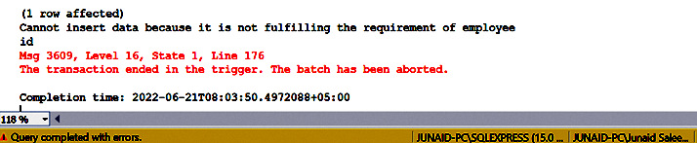('SOAP',9,GETDATE(),GETDATE(),GETDATE(),1,61.00,'Telnet','','','','','')

update orders set freight = 90 where orderid = 10248

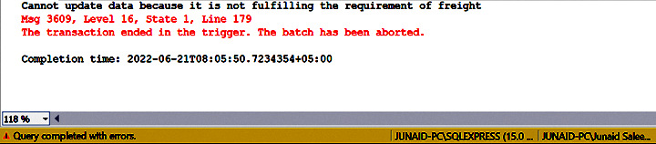

delete from orders where orderid = 10255

